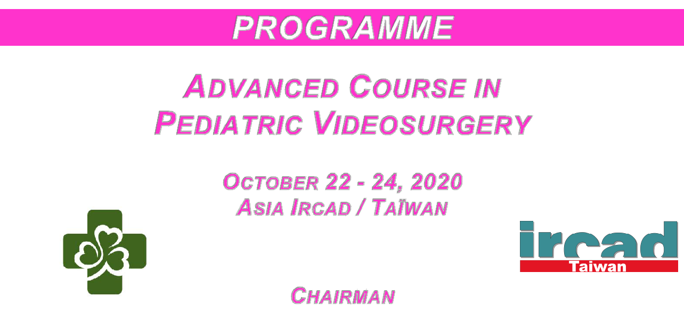

MH. Huang
Show Chwan Memorial Hospital
Changhua, Taïwan

Jacques Marescaux | Wayne HUANG
President, IRCAD | Director, IRCAD-Taiwan
University of Strasbourg, France | Changhua, Taïwan

    - Becmeur
Strasbourg, France

- To cover a broad spectrum of surgical procedures in pediatric surgery

- To provide indications for surgical treatment and discuss operative complications

- To highlight technicalities of surgical interventions through the broadcasting of videos

- To allow discussion between the experts and the surgeon trainees

- To provide hands-on sessions to improve skills in laparoscopic surgery through practice on live tissue under experts’ tutorials

- To describe postoperative clinical results and practical applications of evidence-based clinical medicine

  - Interactive theoretical and video sessions between faculty and course participants

François BECMEUR (France)

Arnaud BONNARD (France)

Paul Chia-Yu CHANG (Taiwan)

Belinda DICKIE (USA)

Yu-Wei FU (Taiwan)

Satoshi IEIRI (Japan)

John MEEHAN (USA)

Paul PHILIPPE (Luxembourg)

Chin-Hung WIE (Taiwan)

V. 17/02/2020

This programme may be subject to modifications or cancellations for timing reasons

Thursday, October 22 - 2020

07.00 PARTICIPANTS SHUTTLE BUS : Hotel to IRCAD Taiwan

FACULTY SHUTTLE BUS : Hotel to IRCAD Taiwan

07.45 Registration

08.00 Welcome to participants

THEORETICAL SESSION

GENERAL ABDOMINAL SURGERY

08.10-08.20 | • | Appendicitis : conventional, transumbilical
 |  | laparoscopy-assisted or single incision
08.20-08.30 | • | Single-incision with glove port for other conditions:
 |  | intussusception, Meckel diverticulum, tumor biopsy

C.H. Wei

C.H. Wei

08.30-08.40

08.40-08.50

08.50-09.10

09.10-09.20

09.40-09.55

09.55-10.05

10.05-10.20

10.20-10.25

10.25-10.40

10.50-11.15

11.15-11.30

11.30-11.40

- Cholecystectomy

- Choledocal cyst

- Total and partial splenectomy

- Splenectomy-single incision Discussion

- Total nephrectomy

- Partial nephrectomy

- Ureteropelvic junction obstruction

- UPJO : vascular hitch

- Vesico-ureteral reflux Discussion

Break

- GER repair : fundoplication and G-Tube

- A laparoscopic fundoplication training simulator with a surgical skill validation system

  - Philippe Y.W. Fu F. Becmeur
  - Meehan

- Philippe Y.W. Fu Y.W. Fu

- Philippe P. Philippe

- Meehan S. Ieiri

11.40-11.50 | • Low esophageal banding for unusual cases | P. C.Y. Chang
Discussion

12.00-12.15 | • Transanal vs laparoscopy, Swenson vs Soave for
 | hirschprung disease
12.15-12.30 | • Laparoscopy for colostomy and reconstruction in
 | anorectal malformations
12.30-12.45 | • Laparoscopy for long common channel of cloaca,
 | urogenital sinus and vaginal atresia
 | Discussion

 | MISCELLANEOUS
13.00-13.10 | • Cryoconservation
 | Lunch
13.10-14.00

  - Dickie B. Dickie B. Dickie

- Becmeur

EXPERIMENTAL LABORATORY - Practice on Live Tissue

14.00 | Each surgical procedure could be performed step by step |  |  |  | All Faculty
 | with the following didactic outlook:
 | 1. | Ergonomics and installation
 | 2. | Introduction and positioning of trocars
 | 3. | Creation of a working space in the abdomen, the
 |  | chest, the retroperitoneum
 | 4. | Instruments and energy applying systems
 | 5. | Dissection
 | 6. | Suturing and knotting

2 groups :

- Group 1 : basic skills and easy procedures

- Group 2 : advanced procedures

18.30 End of the session

This programme may be subject to modifications or cancellations for timing reasons

Friday, October 23 - 2020

07.00 PARTICIPANTS SHUTTLE BUS : Hotel to IRCAD Taiwan

FACULTY SHUTTLE BUS : Hotel to IRCAD Taiwan

THEORETICAL SESSION

THORAX

08.00-08.10 | • | Thoracoscopy : principles | F. Becmeur
08.10-08.30 | • | Indications and technical details | A. Bonnard
 | Discussion

NEONATAL SURGERY

08.45-09.05 | • | Esophageal atresia
09.05-09.25 | • | Congenital diaphragmatic hernia
09.25-09.45 | • Laparoscopy for pyloric stenosis, malrotation and intestinal
 |  | atresia
09.45-10.00 | • Volvulus in Neonates in case of malrotation
10.00-10.15 | • | Duodenal atresia
 | Discussion

  - Bonnard F. Becmeur J. Meehan

- Becmeur A. Bonnard

10.30-11.00 Break

TUMORS

11.00-11.15 | • | Wilm’s tumor | P. Philippe
11.15-11.30 | • | Adrenal gland | F. Becmeur
11.30-11.40 | • Preoperative surgical simulation of laparoscopic adrenalectomy |  | S. Ieiri
 |  | for neuroblastoma using a 3D printed model based on
 |  | preoperative CT images
 | Discussion

MISCELLANEOUS

11.45-12.10 | • | Inguinal hernia repair | P. Philippe
12.10-12.20 | • | Impalpable testis | F. Becmeur
 | Discussion

VIDEO SESSION

12.25-12.35 | • Inguinal hernia repair + discussion | Y.W. Fu
12.25-12.35 | • Feasibility of single-incision laparoscopic percutaneous extra | S. Ieiri
 | peritoneal closure for inguinal hernia by inexperienced pediatric
 | surgeons : single incision versus multi incision randomized trial for 2
 | years + discussion
12.35-12.45 | • video 1 to be confirmed + discussion
12.45-12.55 | • video 1 to be confirmed + discussion
12.55-13.05 | • video 1 to be confirmed + discussion
13.05-13.15 | • video 1 to be confirmed + discussion
13.15-14.00 | Lunch

This programme may be subject to modifications or cancellations for timing reasons

EXPERIMENTAL LABORATORY - Practice on Live Tissue

14.00 | - Gastro-oesophageal reflux | All Faculty
 | - Retroperitoneal approach and transperitoneal approach :
 | Nephrectomy
 | - Oesophageal resection and anastomosis
 | - Thoracoscopy
 | - Partial nephrectomy
 | - Pyloroplasty
 | - Duodeno-jejunostomy
 | - Lich-Gregoir
 | - Vesicoscopy
 | - Patch for a diaphragmatic defect
 | - Lung surgery
18.30 | End of the session

Saturday, October 24 - 2020

07.00 PARTICIPANTS SHUTTLE BUS : Hotel to IRCAD Taiwan

FACULTY SHUTTLE BUS : Hotel to IRCAD Taiwan

EXPERIMENTAL LABORATORY - Practice on Live Tissue

08.00-08.30 | Closing Lecture? | ?
08.30-13.00 | - Gastro-oesophageal reflux | All Faculty
 | - Retroperitoneal approach and transperitoneal approach :
 | Nephrectomy
 | - Oesophageal resection and anastomosis
 | - Thoracoscopy
 | - Partial nephrectomy
 | - Pyloroplasty
 | - Duodeno-jejunostomy
 | - Lich-Gregoir
 | - Vesicoscopy
 | - Patch for a diaphragmatic defect
 | - Lung surgery
13.05 | Lunch
13.45 | End of the seminar
 | Delivery of the certificates of attendance

This programme may be subject to modifications or cancellations for timing reasons

